| **Container Type** | **Internal Dimensions (L x W x H)** | **Door Opening (W x H)** | **Cubic Capacity** | **Cargo Weight** |
| --- | --- | --- | --- | --- |
| 20FT General | 5.89 x 2.35 x 2.36m | 2.33 x 2.26m | 33m³ | 21,700kgs |
| 20FT High Cube | 5.89 x 2.35 x 2.69m | 2.33 x 2.59m | 37m³ | 21,700kgs |
| 40FT General | 12.05 x 2.35 x 2.36m | 2.33 x 2.26m | 66m³ | 26500kgs |
| 40FT High Cube | 12.05 x 2.35 x 2.69m | 2.33 x 2.59m | 76m³ | 26500kgs |
| Container Type | Internal Dimensions (L x W x H) | Door Opening (W x H) | Cubic Capacity | Cargo Weight |
| 20FT Flat Rack with sides | 5.89 x 2.35 x 2.23m | Side Opening W - 2.59m | 30m³ | 26500kgs |
| 20FT Flat Rack without sides | 6.00 x 2.35 x 0.23m |  | 33m³  Max Height 2.36m | 23500kgs |
| 40FT Flat Rack with Sides | 12.05 x 2.35 x 2.23m | Side Opening W - 11.66m | 63m³ | 3600kgs |
| 40FT Flat Rack without sides | 12.20 x 2.35 x 0.65m |  | 67m³ Max Height 2.36m | 39000kgs |
| Container Type | Internal Dimensions (L x W x H) | Door Opening (W x H) | Cubic Capacity | Cargo Weight |
| 20FT Open Top | 5.89 x 2.35 x 2.36m | 2.33 x 2.29m | 32m³ | 21700kgs |
| 40FT Open Top | 12.05 x 2.35 x 2.36m | 2.33 x 2.29m | 66m³ | 26500kgs |

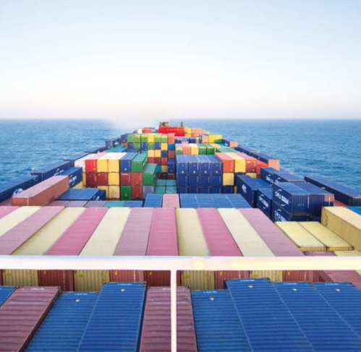

| **Container Type** | **Internal Dimensions (L x W x H)** | **Door Opening** | **Cubic Capacity** | **Cargo Weight** |
| --- | --- | --- | --- | --- |
| 20FT Reefer | 5.44 x 2.26 x 2.24m | 2.26 x 2.20m | 27m³ | 21700kgs |
| 40FT Reefer | 11.55 x 2.26 x 2.24m | 2.26 x 2.20m | 58m³ | 25000kgs |